1. DRV8825 （快递次日达）  
    - can be used in 3D printers and small CNC machines.  
    - support 1/2, 1/4, 1/8, 1/16 and 1/32 microstepping.  
    - can be operated from 8.2 V to 45 V and can deliver up to approximately 1.5 A per phase.  
   Amazon link: [AZDelivery 3 x DRV8825 Stepper Motor Driver Module with Heatsink compatible with Arduino, RAMPS 1.4 / CNC-Shield / 3D printer/Prusa Mendel including E-Book! : Amazon.co.uk: Business, Industry & Science](https://www.amazon.co.uk/AZDelivery-A4988-Dmos-Stepper-Complete-Heatsink/dp/B07CNJR2Z6?ref_=ast_sto_dp&th=1)  
   Data sheet: [DRV8825 data sheet, product information and support | TI.com](https://www.ti.com/product/DRV8825?utm_source=google&utm_medium=cpc&utm_campaign=asc-mdbu-null-prodfolderdynamic-cpc-pf-google-eu_int&utm_content=prodfolddynamic&ds_k=DYNAMIC+SEARCH+ADS&gclid=CjwKCAiA85efBhBbEiwAD7oLQI001dBxcvHEX7Ljqh0iWWEVh_6pDNvgsIweBjA6rGkkZzilX1_3hRoCFpwQAvD_BwE&gclsrc=aw.ds)  
   A picture containing diagram

   Description automatically generated
2. L298N （快递次日达）  
    - 好像很常用，YouTube上见得比较多，亚马逊上大概1/5 valid的选项都是这个板  
    - Double H bridge design, can drive **one 2-phase stepper motor, one 4-phase stepper motor or two DC motors**, high efficient; voltage **5V-35V**, drive current **2A (Max single bridge)**  
   [Dealikee 5Pack L298N Stepper Motor Driver Controller Board Dual H Bridge Module for Smart Car Power MEGA R3 Mega 2560 : Amazon.co.uk: Business, Industry & Science](https://www.amazon.co.uk/Dealikee-Stepper-Controller-Arduino-Mega2560/dp/B08FG1M31L/ref=sr_1_2_sspa?crid=10DFSJY752CB5&keywords=L298N&qid=1676060979&sprefix=l298n%2Caps%2C63&sr=8-2-spons&sp_csd=d2lkZ2V0TmFtZT1zcF9hdGY&psc=1)  
   Datasheet: [Dual full-bridge driver (heisener.com)](https://dir.heisener.com/DatasheetDownload/L298P.pdf)  
   A picture containing timeline

   Description automatically generated
3. PCA9685 16 channel 12 bit PWM servo driver for Raspberry Pi（次日达）  
    - PCA9685 16-Channel 12-bit PWM Servo Driver is highly compatible with **3.3 V - 5 V I²C connection** with choice of 62 selectable addresses, up to 992 PWM signals are controllable with only one controller.  
    - **220 Ohm resistance at each output** for comfortable Servo and LED control  
   Amazon link: [AZDelivery 3 x PCA9685 16-Channel 12-bit PWM Servo Driver compatible with Arduino and Raspberry Pi Including E-Book! : Amazon.co.uk: Computers & Accessories](https://www.amazon.co.uk/AZDelivery-PCA9685-16-Channel-Raspberry-Controllers/dp/B07CRDCP8V/ref=sr_1_1_sspa?crid=2QUZQOTH6M2S5&keywords=PCA9685&qid=1676069233&sprefix=pca9685%2Caps%2C89&sr=8-1-spons&sp_csd=d2lkZ2V0TmFtZT1zcF9hdGY&psc=1&smid=A1X7QLRQH87QA3)  
   Datasheet （有点长）: [PCA9685 pdf, PCA9685 Description, PCA9685 Datasheet, PCA9685 view ::: ALLDATASHEET :::](https://pdf1.alldatasheet.com/datasheet-pdf/view/750522/PHILIPS/PCA9685.html)  
   A picture containing diagram

   Description automatically generated
4. AZDelivery CNC Shield V3 Development Board for A4988 Stepper Motor Driver compatible with Arduino, 3D Printer（快递两日达）  
    - has 4 Axis support (X, Y, Z , A-Can duplicate X,Y,Z or do a full 4th axis with custom firmware using pins D12 and D13); input voltage **12 V - 36 V**Amazon: [AZDelivery CNC Shield V3 Development Board for A4988 Stepper Motor Driver compatible with Arduino, 3D Printer including E-Book! : Amazon.co.uk: Business, Industry & Science](https://www.amazon.co.uk/dp/B07CZDC9TZ/ref=twister_B081TLWZRP?_encoding=UTF8&psc=1)  
   Datasheet: 找不到  
   Diagram

   Description automatically generated
5. AZDelivery L293D Motor Driver Shield, 4-Channel Motor Driver Shield, Stepper Motor, Stepper Expansion Board compatible with Arduino（快递次日达）  
    - The AZDelivery Shield L293D with 2 connections for **5V** servo motors with timer connection for a smooth control. The L293D Motor Driver Shield is designed to easily plug into the controller for efficient prototyping; the shield connects to one board to control up to **4 DC motors, 2 stepper motors or 2 servo motors** that can be powered **up to 36V**; **600mA** per channel   
   Amazon: [AZDelivery L293D Motor Driver Shield, 4-Channel Motor Driver Shield, Stepper Motor, Stepper Expansion Board compatible with Arduino Including E-Book! : Amazon.co.uk: Business, Industry & Science](https://www.amazon.co.uk/AZDelivery-L293D-4-channel-Diecimila-Duemilanove/dp/B07CZZVPZV/ref=sr_1_1?crid=5DVWOYJEP0XP&keywords=AZDelivery+L293D+Motor+Driver+Shield%2C+4-Channel+Motor+Driver+Shield%2C+Stepper+Motor%2C+Stepper+Expansion+Board+compatible+with+Arduino&qid=1676069942&sprefix=azdelivery+l293d+motor+driver+shield+4-channel+motor+driver+shield+stepper+motor+stepper+expansion+board+compatible+with+arduino%2Caps%2C56&sr=8-1)  
   Datasheet: [L293x Quadruple Half-H Drivers datasheet (Rev. D) (ti.com)](https://www.ti.com/lit/ds/symlink/l293d.pdf?ts=1676016595107&ref_url=http%253A%252F%252Fwww.datasheet.es%252F)  
   Diagram

   Description automatically generated
6. A4988 Stepper Motor Driver Module + Heat Sink for 3D Printer Reprap （四天快递）  
    - Five different step resolutions: full-step, half-step, quarter-step, eighth-step, and sixteenth-step. Output drive capacity of **up to 35 V and ± 1.2 A （datasheet上写的是2A）**  
    - Adjustable current control lets you set the maximum current output with a potentiometer  
    - Intelligent chopping control that automatically selects the correct current decay mode (fast decay or slow decay)  
    - Over-temperature thermal shutdown, under-voltage lockout, and crossover-current protection  
   Amazon: [A4988 Stepper Motor Driver Module + Heat Sink for 3D Printer Reprap : Amazon.co.uk: Business, Industry & Science](https://www.amazon.co.uk/Stepper-Driver-Module-Printer-Reprap/dp/B08R64Y7V7/ref=sr_1_12_sspa?crid=2OV86W1BO3UY4&keywords=arduino+motor+driver+shield&qid=1676065247&sprefix=arduino+motor+driver%2Caps%2C115&sr=8-12-spons&sp_csd=d2lkZ2V0TmFtZT1zcF9tdGY&psc=1)  
   Datasheet: [A4988 pdf, A4988 Description, A4988 Datasheet, A4988 view ::: ALLDATASHEET :::](https://pdf1.alldatasheet.com/datasheet-pdf/view/338780/ALLEGRO/A4988.html)  
   Diagram

   Description automatically generated
7. Adafruit TB6612 1.2A DC/Stepper Motor Driver Breakout Board  
    - Spin **two DC motors, step one bi-polar or uni-polar stepper,** or fire off two solenoids with **1.2A per channel** using the TB6612.   
    - There's two digital inputs per H-bridge (one for each half of the bridge) as well as a PWM input per driver so you can control motor speed. Runs at **2.7V-5V logic**. The motor voltage is separate from the logic voltage. Good for motor voltages from 4.5V up to 13.5V! This won’t work well for 3V motors.  
   Buy: [Adafruit TB6612 1.2A DC/Stepper Motor Driver Breakout Board (pimoroni.com)](https://shop.pimoroni.com/products/adafruit-tb6612-1-2a-dc-stepper-motor-driver-breakout-board?variant=3225743105&currency=GBP&utm_source=google&utm_medium=cpc&utm_campaign=google+shopping?utm_source=google&utm_medium=surfaces&utm_campaign=shopping&gclid=CjwKCAiAlp2fBhBPEiwA2Q10D9mlE5WyBVBHB1e-anAQ26MASxgzm6Ts1lI6xptM3KjVblnQCEgJrBoCAtEQAvD_BwE)  
   A picture containing indoor

   Description automatically generated
8. Adafruit DRV8871 DC Motor Driver Breakout Board - 3.6A Max  
    - （数据见表）  
   Buy: [Adafruit DRV8871 DC Motor Driver Breakout Board - 3.6A Max : ID 3190 : $7.50 : Adafruit Industries, Unique & fun DIY electronics and kits](https://www.adafruit.com/product/3190#description)  
   Datasheet: [DRV8871 3.6-A Brushed DC Motor Driver With Internal Current Sense (PWM Control) (Rev. B) (adafruit.com)](https://cdn-shop.adafruit.com/product-files/3190/drv8871.pdf)  
   A close-up of a microchip

   Description automatically generated with medium confidence
9. Adafruit DRV8833 DC/Stepper Motor Driver Breakout Board  
    - （数据见表）  
   Buy: [Adafruit DRV8833 DC/Stepper Motor Driver Breakout Board : ID 3297 : $5.95 : Adafruit Industries, Unique & fun DIY electronics and kits](https://www.adafruit.com/product/3297)  
   Datasheet: [DRV8833 Dual H-Bridge Motor Driver (Rev. D) (adafruit.com)](https://cdn-learn.adafruit.com/assets/assets/000/039/902/original/drv8833.pdf?1488941266)  
   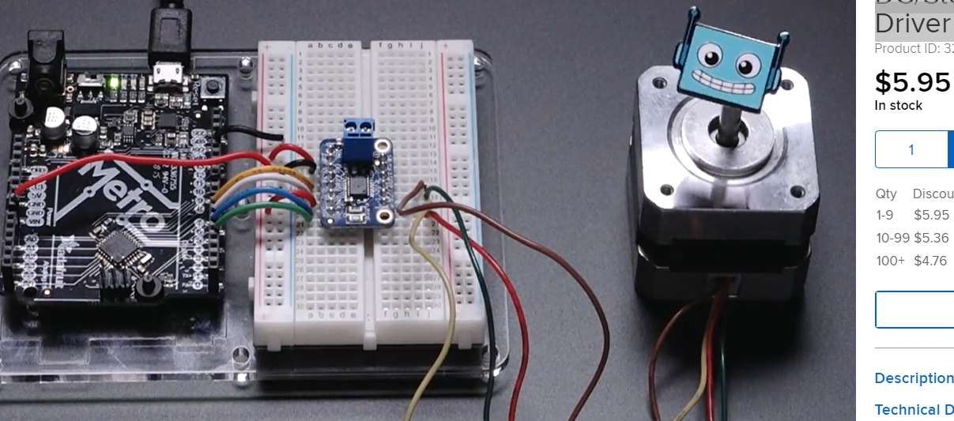
10. A4950  
     - 纯芯片，没板子（装好板子的快递二月底到）  
    Buy: [A4950ELJTR-T Allegro Microsystems, Full Bridge DMOS PWM Motor Driver, 40V/3.5A/2 Outputs, SOIC-8 | Farnell UK](https://uk.farnell.com/allegro-microsystems/a4950eljtr-t/motor-dvr-full-brdg-8soic/dp/2057412?st=a4950)  
    Datasheet: [4950.indd (farnell.com)](https://www.farnell.com/datasheets/2044376.pdf)  
    A picture containing text, electronics

    Description automatically generated
11. L9110  
     - （数据见表）  
    Buy: [DollaTek 5PCS L9110 L9110S two channel motor driven plate motor drive module: Amazon.co.uk: Electronics & Photo](https://www.amazon.co.uk/DollaTek-L9110S-channel-driven-module/dp/B07DK4FMWR/ref=sr_1_1_sspa?crid=UAOAR8BC5ELV&keywords=L9110&qid=1676127907&sprefix=l9110%2Caps%2C94&sr=8-1-spons&sp_csd=d2lkZ2V0TmFtZT1zcF9hdGY&psc=1)  
    Datasheet: [L9110 pdf, L9110 Description, L9110 Datasheet, L9110 view ::: ALLDATASHEET :::](https://pdf1.alldatasheet.com/datasheet-pdf/view/1133007/ETC2/L9110.html)  
    A picture containing text

    Description automatically generated